

Khwaja Yunus Ali University

***Lab Report -06***

**Name of the Department: Computer Science and Engineering**

**Course Code: CSE 0713-1104**

**Course Title: Electrical Circuit Lab**

**Experiment No.: 06**

**Name of the Experiment : Verification of Superposition Theorem using Simulation.**

**Date of Experiment : 23-03-2025**

**Date of Submission : 30-03-2025**

**Instructor Signature & Date**

|  |  |  |
| --- | --- | --- |
| **Submitted by –** |  | **Submitted to –** |

**Name: Md Sojib Ahmed**  **Name: Sakil Ahammed**

ID Number: 06224205101006 Lecturer

Batch No: 18th Department of EEE

Semester: 1st year 2nd Semester Khwaja Yunus Ali University

Khwaja Yunus Ali University

**Name of the Experiment:**

**Verification of Superposition Theorem using Simulation.**

**Objective:**

To verify the Superposition Theorem using digital simulation software (Proteus) and compare the calculated and simulated results.

**Theory:**

The Superposition Theorem states that in any linear bilateral network with multiple independent sources, the response (current or voltage) in any element is equal to the algebraic sum of the responses caused by each independent source acting alone, while all other sources are replaced by their internal resistances.

* Voltage source is replaced with a short circuit.
* Current source is replaced with an open circuit.

**Circuit Diagram:**

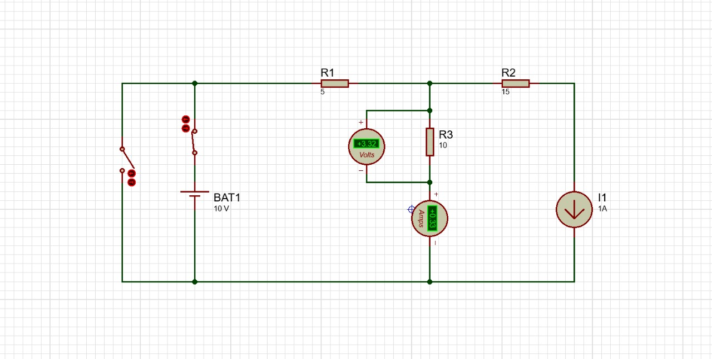

Fig. (1) Super position theorem

**Apparatus Used:**

* Software: Proteus 8 Professional
* DC Voltage Source: 10V
* DC Current Source: 1A
* Resistors: R1 = 5Ω, R2 = 15Ω, R3 = 10Ω
* Voltmeter & Ammeter
* Connecting Wires

**Working Procedure:**

1. The circuit is designed in Proteus using one voltage source (10V) and one current source (1A) with three resistors.
2. Switches are used to isolate the voltage source and the current source individually to apply Superposition Theorem.
3. First, the current source is kept open (disabled), and only the voltage source is active. Voltages and currents are measured using virtual meters.
4. Then, the voltage source is shorted (disabled), and only the current source is active. Again, readings are taken.
5. The total response is found by algebraically adding the responses due to each source.
6. All measurements are recorded, and theoretical calculations are done using Ohm’s Law and basic circuit laws.
7. Results from simulation and calculation are compared.

**Calculations:**

**Given:**

* Voltage source: 10V
* Current source: 1A
* R1 = 5Ω, R2 = 15Ω, R3 = 10Ω

**Step 1: When Only Voltage Source is Active (Current Source Open)**

* Total resistance in series:
$$R_{total }=R1+R3=5Ω+10Ω=15Ω$$

* Current through the loop:
$$I=\frac{V}{R_{total }}=\frac{10 V}{15Ω}=0.666 A$$

* Voltage across R3:

$$V_{R3}=I×R3=0.666 A×10Ω=6.66 V$$

**Step 2: When Only Current Source is Active (Voltage Source Shorted)**

* R1 and R2 are in series:
$$R_{eq1}=R1+R2=5Ω+15Ω=20Ω$$

* R3 is in parallel with R_eq1:
$$\begin{matrix} & \frac{1}{R_{\text{total }}}=\frac{1}{R_{\text{eq1 }}}+\frac{1}{P3}=\frac{1}{20}+\frac{1}{10}=\frac{3}{20} \\ & R_{\text{total }}=\frac{20}{3}≈6.67Ω\end{matrix}$$

* Voltage across R3:
$$V=I×R_{total}=1A×6.67Ω=6.67V$$

* Current through R3 (by Ohm's Law):

$$I_{R3}=\frac{V}{R3}=\frac{6.67V}{10Ω}≈0.667 A$$

**Step 3: Total Response by Superposition**

* Voltage across R3:
$$\begin{matrix} & V_{R3(\text{ Total })}=V_{R3(\text{ VoltageSource })}+V_{R3(\text{ CurrentSource })} \\ & =6.66 V+3.32 V=9.98 V≈10 V\end{matrix}$$

* Current through R3:

$$I_{R3(\text{ Total })}=0.333A(\text{ VoltageSource })+0.333A(\text{ CurrentSource })=0.666A$$

**Observation Table:**

| **Source Condition** | **Voltage across R3 (V)** | **Current through R3 (A)** |
| --- | --- | --- |
| Only Voltage Source | 6.66V | 0.333A |
| Only Current Source | 3.32V | 0.333A |
| Total (By Superposition) | 9.98V ≈ 10V | 0.666A |
| From Simulation | 10V | 0.66A |

**Result and Discussion:**

* The experimental and theoretical values are almost the same, verifying the Superposition Theorem.
* Minor differences in values may be due to simulation rounding or display limitations.
* Both sources acting together produced a result that matched the sum of individual contributions.

**Conclusion:**

The Superposition Theorem was successfully verified using simulation in Proteus. The total response of the circuit matched the sum of individual responses from each source, validating the theoretical principle.